PRESS RELEASE FOR “JAZZ AND COMEDY AT THE COLLEGE” – 1ST APRIL 2017
Guests attending the Old Farnhamians and Farnham Sixth Form College show entitled “Jazz and Comedy at the College” received quite shock as they entered the reception area and were faced with show band leader, Geoff Hiscott dressed as a Headmaster in gown, mortar board and wielding a cane. They were urged to take their seats or get “six of the best” and were escorted to the Performance Hall at Morley Road by current students dressed in St. Trinians garb. This set the tone for a first class evening of entertainment.
After a brief introduction by Cyril Trust, the event organiser, Geoff Hiscott led his show band into a series of jazz classics beginning with “Take the A Train” by Duke Ellington. As usual his musicians were masters of their instruments and soon had the audience in the swing of things. Guest trumpet player, Tim Eyles sang an enjoyable version of “ I’m the King of the Swingers” from Jungle Book to finish the first set.
The first guest on stage was Tegan Creedy, a former pupil of the College, who began with “Sway” and then a wonderful rendition of “Someone to Watch over Me”. Tegan, who recently obtained an honours degree in Law, has a distinctive voice and the audience sat spellbound as her songs filled the hall. She is an exceptional talent.
Back to the show band and the humour of their leader who soon had guests laughing as he selected certain people to joke with about their school days. More jazz, speciality songs followed and then Quintessential took to the stage. Sue Lampard and her quintet of ladies produced a lovely blend of voices and sang some close harmony songs finishing their set with a rousing “Rhythmn of Life”.
Nick Ridley with electric guitar followed with “The Days of Wine and Roses”, and “The Wind Beneath my Wings” and a version of Another Brick in the Wall”, the old Pink Floyd hit, with the audience taking part. A perfect choice of songs and some excellent guitar work.
The second half began with more good music from the band, including a superb version of “Misty”. Back came Tegan Creedy, with “Cheek to Cheek” and a really excellent version of “At Last”. Truly a voice to remember and songs to savour.
Geoff Hiscott then introduced members from the Farnham College Music Group who sang and played “Upside Down”, a well known Paloma Faith hit. Catherine Bookham, the leader of the group, then played a beautiful violin piece entitled “Gavi’s Song”, which brought loud applause from this and song.
Nick Ridley played and sang “The Way You Look Tonight” and a George Benson classic “Masquerade.”After a quick change he turned to his banjo and played the old favourite “Ghost Riders in the Sky” complete with new words. He was followed by the ladies from Quintessential who sang a ten minute Beatles Medley covering ten of their songs.
Finally, after more jazz and comedy numbers from the band, the finale with the band playing “The Dambusters March” and Peter Templeman parading around the hall complete with spitfire. It has to be seen to believe this!
This was a special evening for the college, the Old Boys and the 150 plus audience. It is hoped that £1000 was the result and these proceeds will go to the college to purchase computer equipment.
Dr. Jason Jones thanked the organiser, the performers and the helpers and wished everyone a safe journey home. This was a new experience for the college and a possible repeat will be considered for 2018.

CYRIL TRUST – APRIL 2017
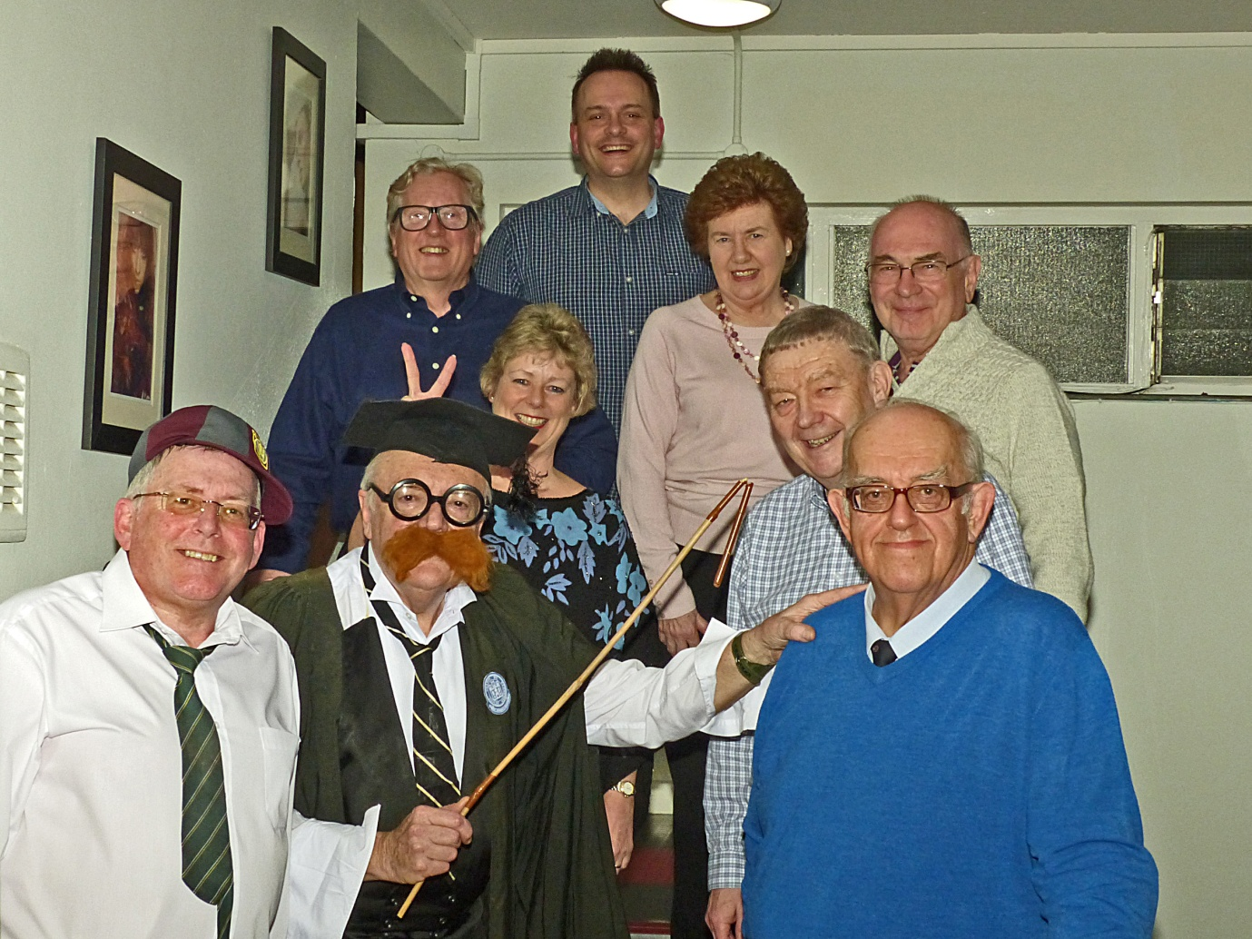
Front: Nick Ridley: Headmaster Geoff Hiscott: Cyril Trust (Organiser): Second Row: Sue Lampard (Quintessential): Roger Edgell (President of the Old Boys): Back Row: Richard Phillips (Old Boys Vice-President): Jason Jones (Director of Farnham Sixth Form College): Wendy Craig (Chief Executive for Tindle Newspapers): Brian Wiliams (Secretary for Old Boys).

